Physical Education Lesson for the Week
April 20th-24th is Every Kid Healthy Week
During this week try to be as active as you can to join others across the country in celebrating Every Kid Healthy Week!
- We have covered all the Muscles of the Month for the school year. Currently, we are going to do a muscle of the week each week. This will be a review of all the muscles we have talked about throughout the year. Review the muscle with your child by saying what the muscle is for the week. Have them show you where it is on their body. Next, show them the picture on the slides to see if they were correct. Finally, explain what it is used for or have them explain what it is used for (attached you can use the slides/pictures to assist with your child).

- Continue Each Day During April to perform the activities on that specific day using your April activity calendar attached.

- This week we are going to coordinate all activities and exercises with the muscle of the week – Gluteus Maximus.

Monday – Perform 10 Squat Jumps

Tuesday – Perform 20 mountain climbers

Wednesday- Perform 30 Straight Leg Raises (15 per leg) or Kick a ball 30 times

Thursday – Perform 40 Jumping Jacks

Friday – Self – Test day- Perform for as long as you can without stopping any movement you want. Examples may be hopping around, running, jogging, skipping, playing tag, and jumping rope. Whatever movement you attempt, try not to stop moving. This will be a great way to test your endurance for the week once you have completed all the daily fitness routines.

Try the Following for Friday’s Self-Test Day:
5 Minutes of movement without stopping = Fitness Level
or
10 Minutes of movement without stopping = Titan Level

***If you really want to challenge yourself – Try using the mile run, ½ mile, and ¼ run charts provided below to see how good your endurance really is. This is extra just to help any of the kids try to see how in shape they really are for their age level while working their gluteus maximus. – Let us know how you do, if you try this on your own. Have Fun!

Be Safe, Be Healthy, Stay Active!
Shaler Area School District
Primary PE Department
Yours in Fitness and Health,
Mr. Chmielewski
Muscle of the Week

Muscle of the Week

Function of the Gluteus Maximus
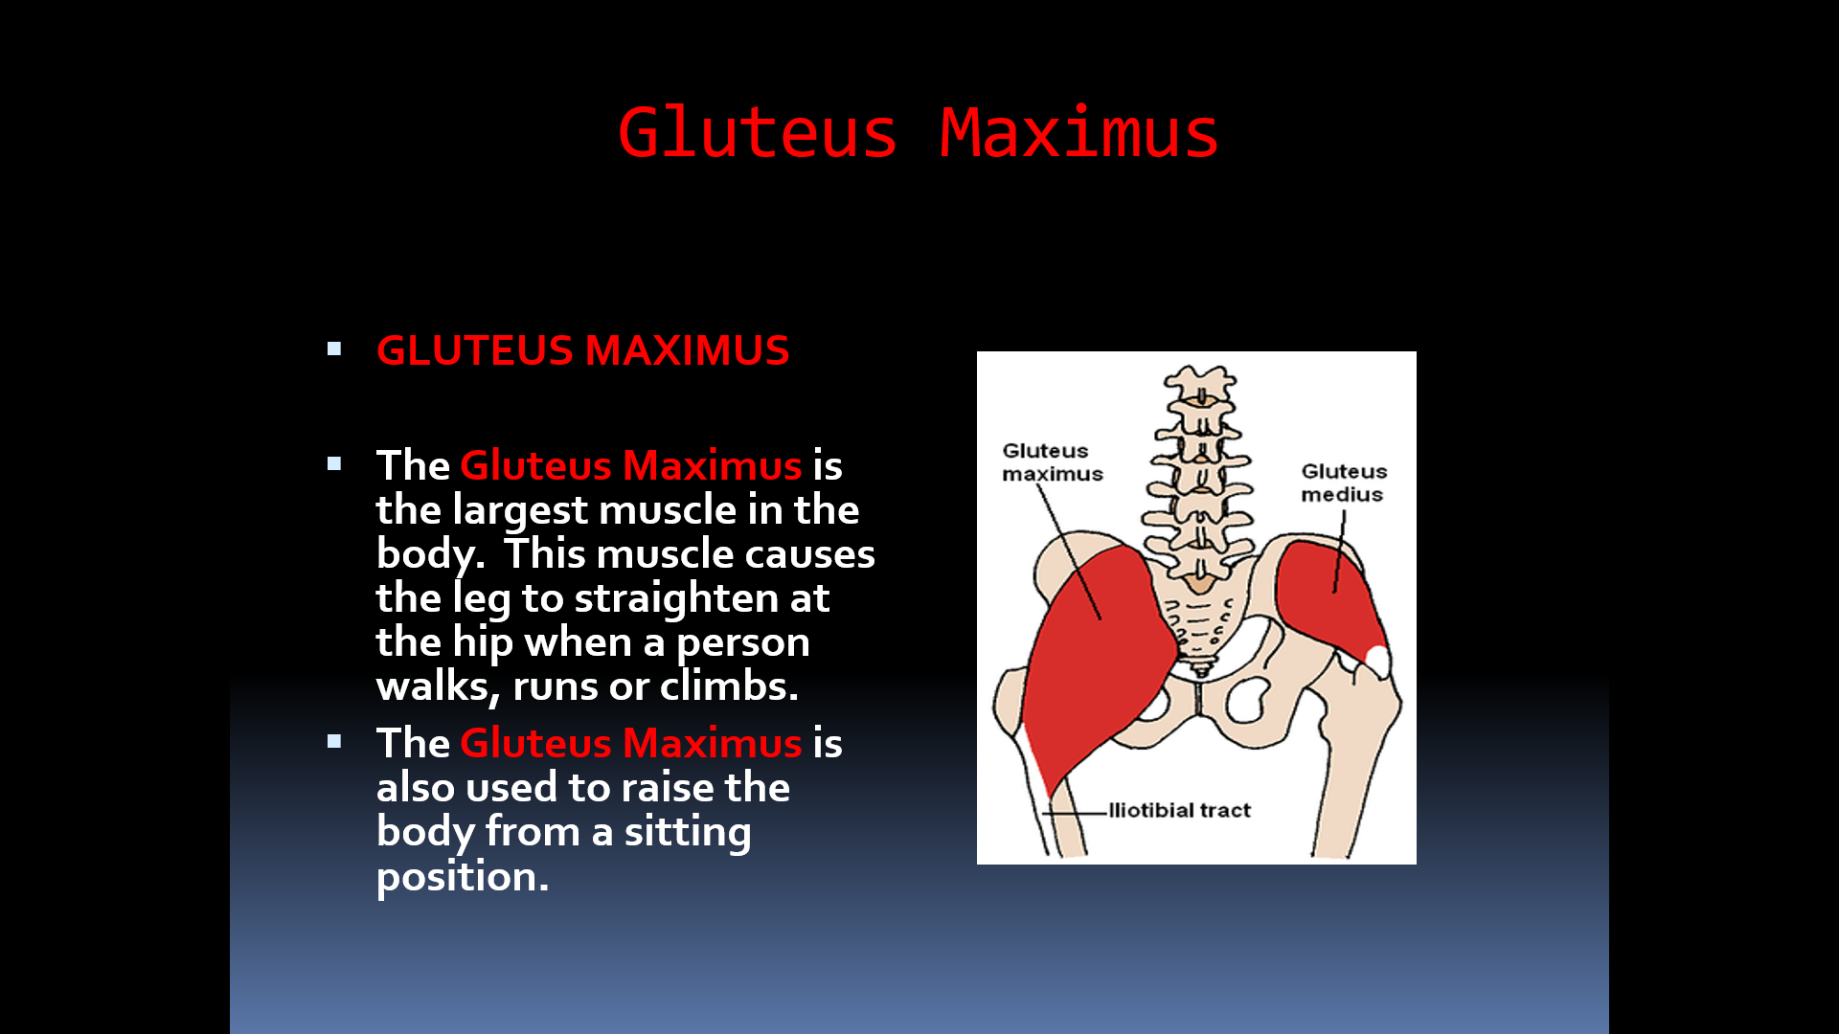

How do we use these muscles in PE?
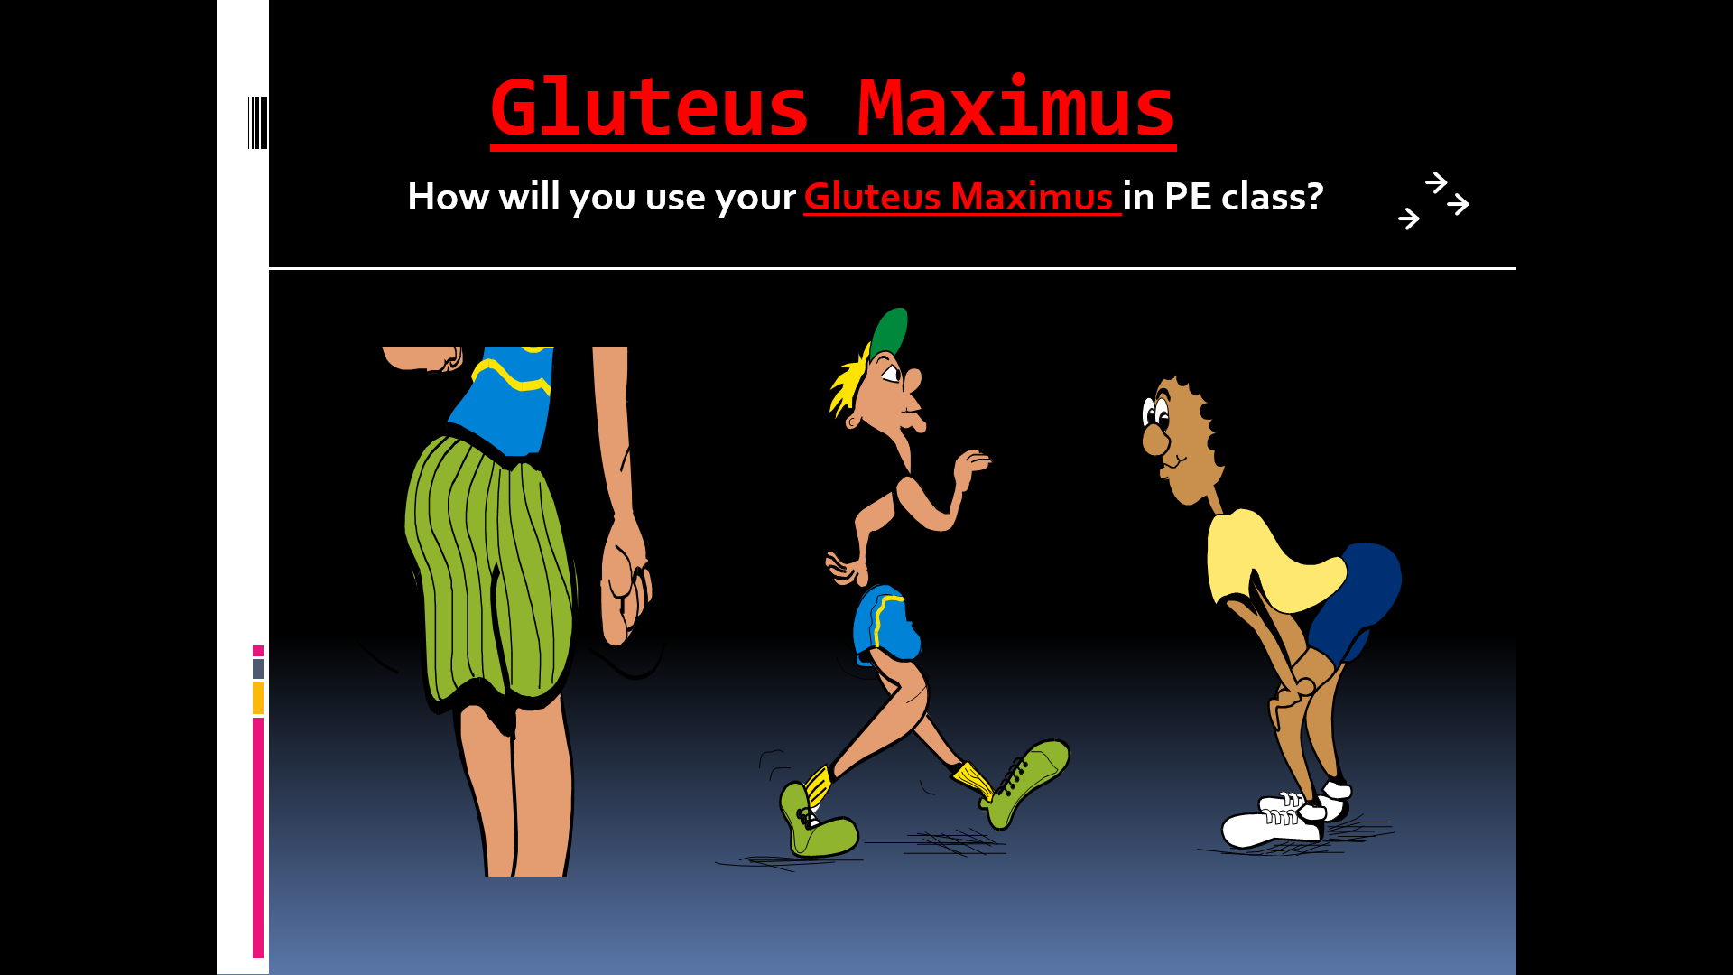
Fitness Tests we use the Gluteus Maximus for in PE CLASS!
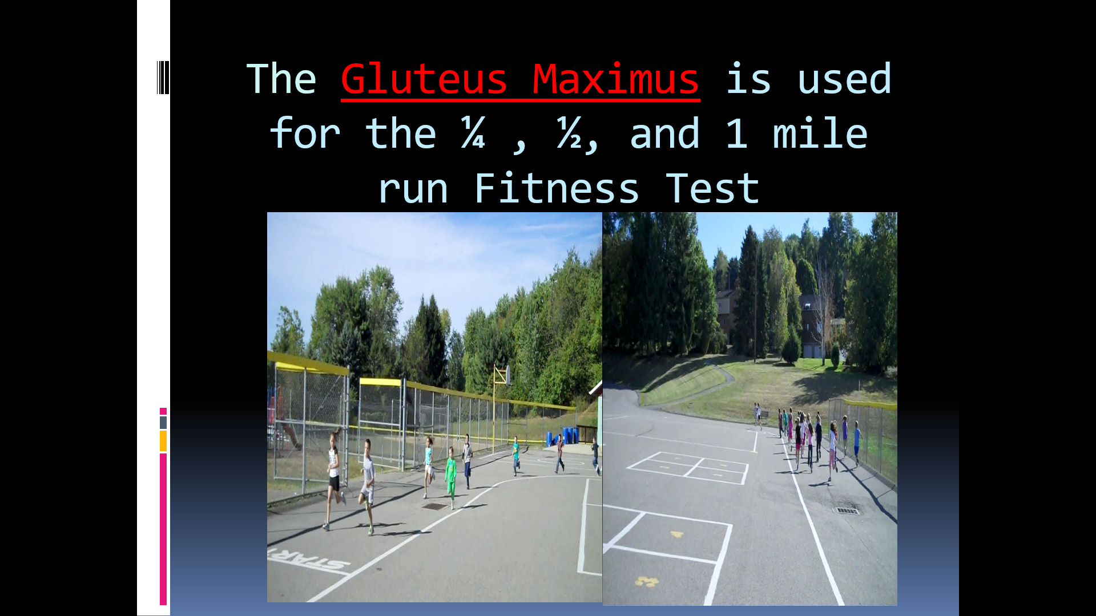
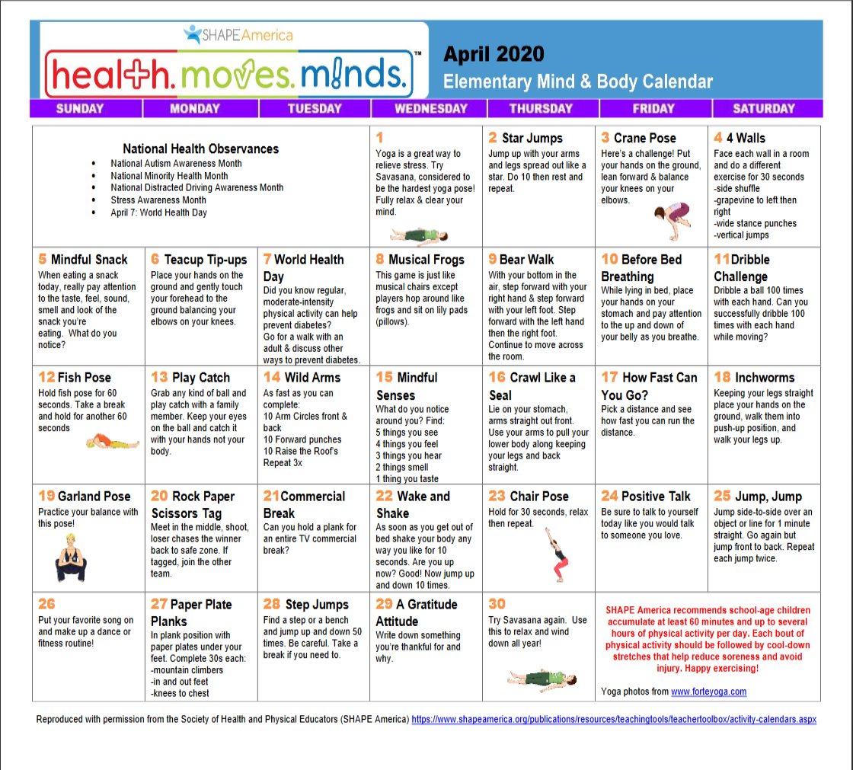

0NE-MILE RUN

(minutes/seconds)
AGE | BOYS  ~  FITNESS | BOYS  ~  TITAN | GIRLS  ~  FITNESS | GIRLS  ~  TITAN
6 | 12:36 | 10:15 | 13:12 | 11:20
7 | 11:40 | 9:22 | 12:56 | 10:36
8 | 11:05 | 8:48 | 12:30 | 10:02
9 | 10:30 | 8:31 | 11:52 | 9:30
10 | 9:48 | 7:57 | 11:22 | 9:19
11 | 9:20 | 7:32 | 11:17 | 9:02

¼ MILE RUN
(minutes/seconds)
AGE | BOYS  ~  FITNESS | BOYS  ~  TITAN | GIRLS  ~  FITNESS | GIRLS  ~  TITAN
6 | 2:21 | 1:55 | 2:26 | 2:00
7 | 2:10 | 1:48 | 2:21 | 1:55
8 | 2:05 | 1:40 | 2:10 | 1:45
½ MILE RUN
(minutes/seconds)
7 | 4:45 | 3:53 | 5:16 | 4:18
8 | 4:30 | 3:38 | 5:04 | 4:06
9 | 4:14 | 3:30 | 4:50 | 3:53

